How to move file from source server to target server?

1.server up 2 server

2. peering establish between 2 server

3.geneate ssk-keygen from source server and copy the public key & pasted in target server

4.scp -p filename targetserverip:/target server path

Peering established

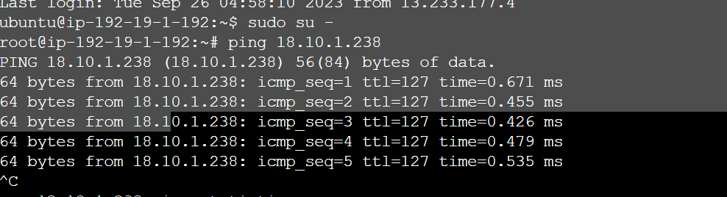

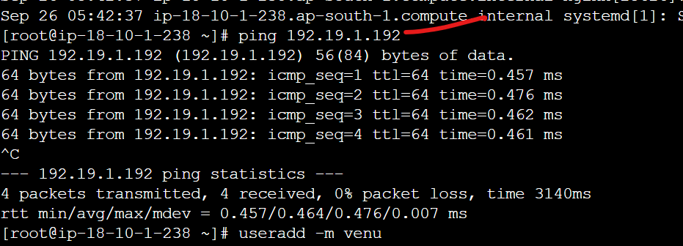

By using wget file install file

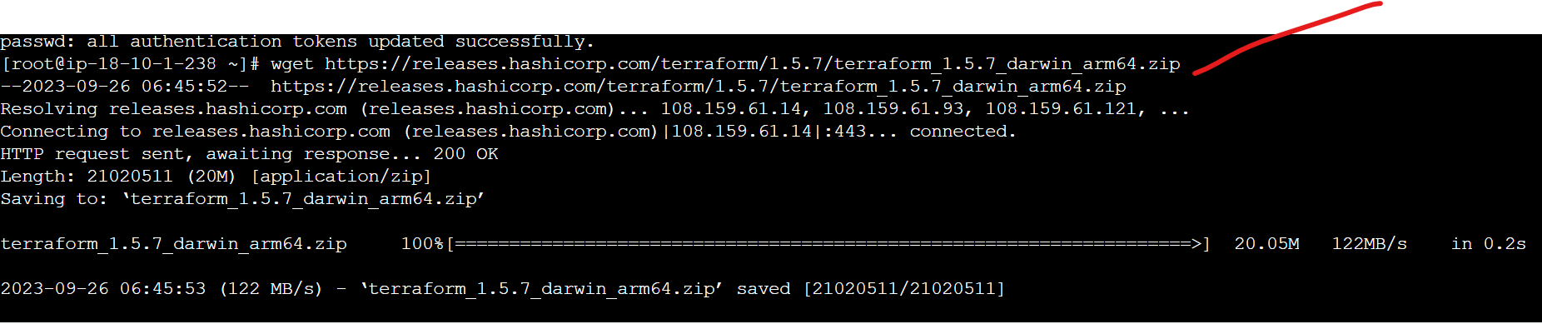

User created in target server

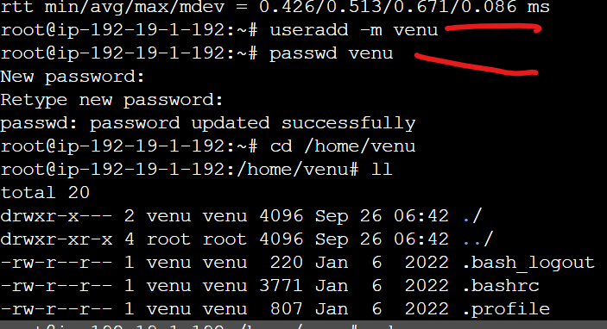

Access denied error

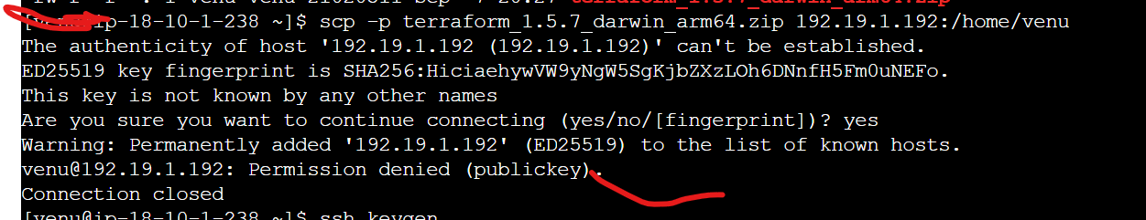

Ssh-keygen generate in source server

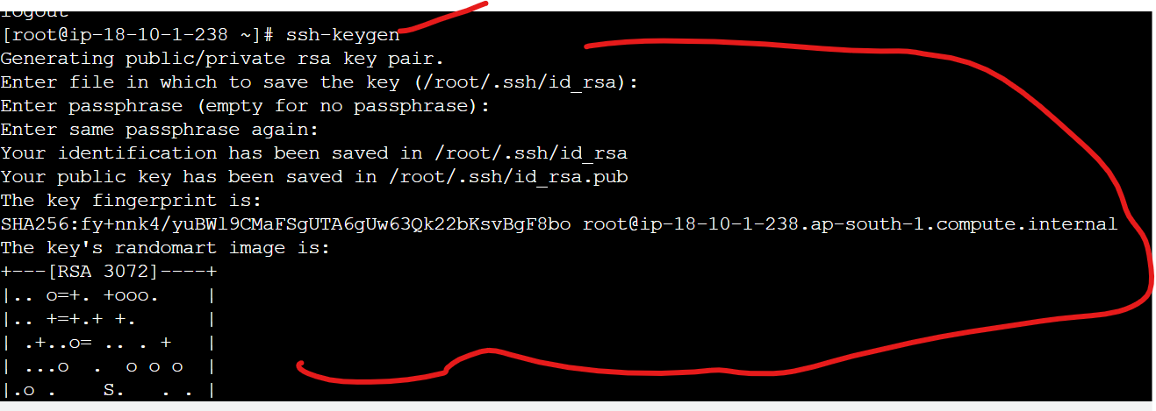

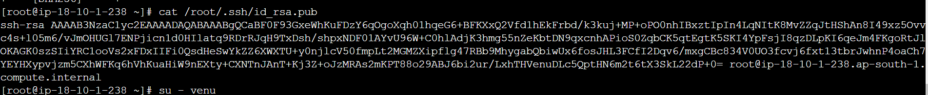

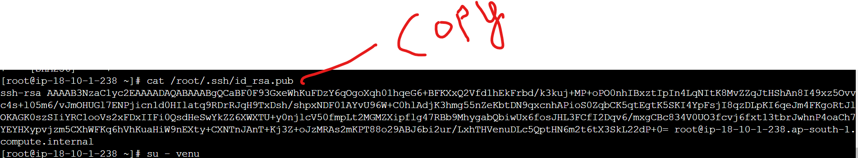

Paste in target server

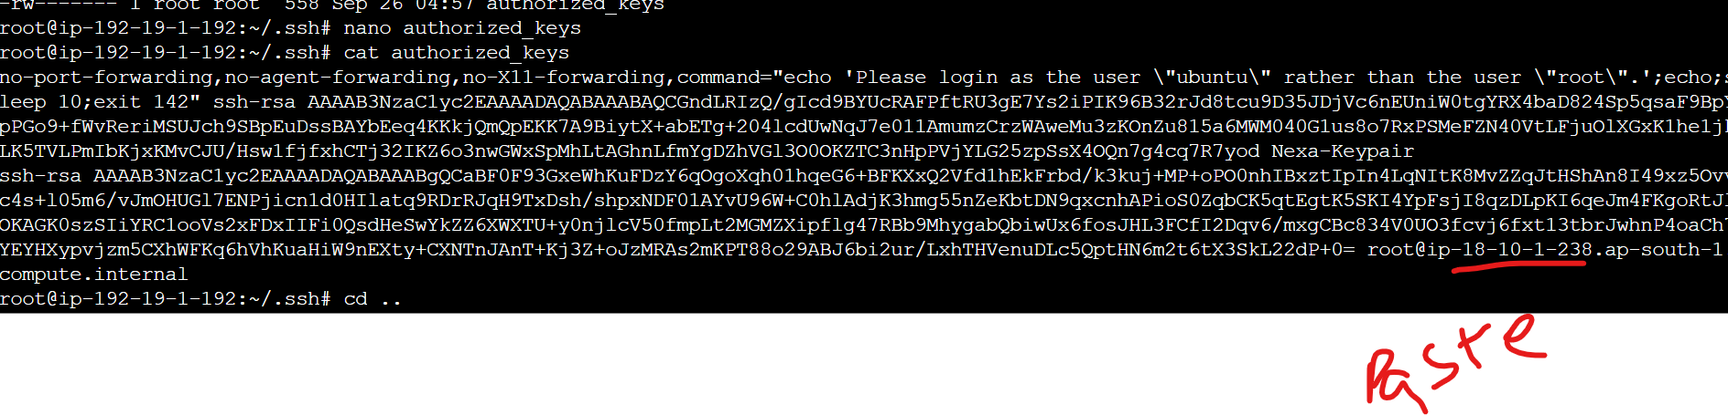

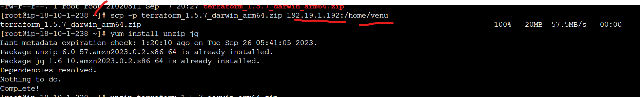

Output:

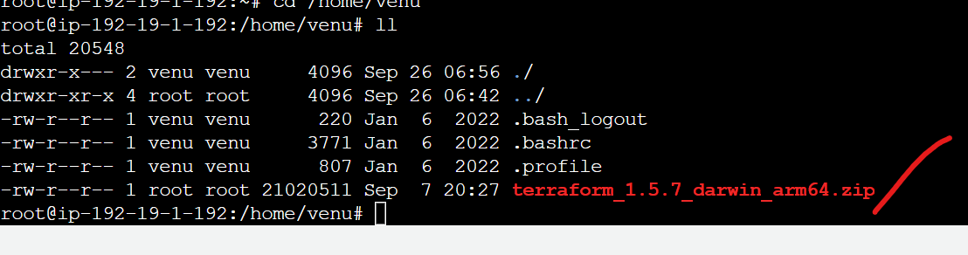

Destination Server CMDS

1 apt update

2 apt install nginx -y

3 service nginx start

4 service nginx status

5 exit

6 ll

7 cd .ssh/

8 ll

9 nano authorized_keys

10 cat authorized_keys

11 cd ..

12 ls

13 cd /home/venu

14 ll

15 history

16 ping 18.10.1.238

17 useradd -m venu

18 passwd venu

19 cd /home/venu

20 ll

21 cd ..

22 ll

23 cd .ssh

24 sudo su -

25 history